
Cameron’s Collection @ your KCHS Library

It’s okay to have bad days, to not feel your best—you’re not alone. When you’re ready to talk—or just want to learn more—you have 24/7 access to resources that can help. Search through the eBooks in Cameron’s Collection. It’s completely private and tackles everything from stressing over school to dealing with tough relationships.
Scan the QR Code and go directly to the books!

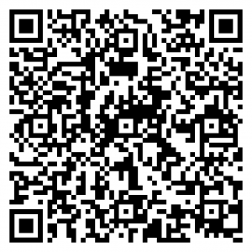

Access books at your library website too! Need help ask Ms. Gann in the library!

